考 試 命 題 紙
注意：1、本原稿直接製版請以黑色原子筆正楷書寫並自行斟酌答案之空格  2、試題難易請適當分配  3、考試時間 60 分鐘（第18週 97/06/23〜97/06/28）  4、請於97年06月14日以前送交進修部教務組印製  5、須使用計算機請於試題紙上勾選 |  |  | 命題者：郭月華 老師  科 目：  ( )學生需要答案紙  ( )學生不需要答案紙
中華技術學院四技96學年度第2學期 大一英文期末考
考試科目： 考試班級： 學號 姓名 共 頁第 頁
（）可使用計算機 | （）不可使用計算機 | ★如該科附有答案卷★  若答案寫在試題卷上而未填寫在答案卷上，則該科將不予計分。

I. 單字與片語測驗
A. batteries | B. hit | C. landlord | D. flooded | E. in case of
F. suggested | G. excitement | H. get ready for | I. failure | J. warning

- We had some ___ because there was no school tomorrow.
- When the storm came, they were worried our house would be ___ because we lived in a low area.
- We need ___ for a flashlight.
- My ___ came and helped us fix the broken windows.
- My parents ___ that we store water in the bathtub before the typhoon came.
- When the radio gave a typhoon ___ last month, we were worried about that.
- Greg’s father called and told him to ______ the typhoon.
- We may need candles and matches ___ a power breakdown.
- Power _____ may happen during an earthquake.
- The typhoon was leaving and wouldn’t ___ this area at all!

II. 文法測驗
- It was the first typhoon after Greg and I ___.
A got married B. marry C. have been married D. were marrying
- The TV news said that the typhoon was going ___ the north.
  - up B. toward C. about D. on
- John came over our house last night and ___us how to prepare for the typhoon.
  - teaches B. teaching C. taught D. had taught
- Some mistakes ___ in your paper, but I’ve already corrected them for you.
  - were found B. found C. were finding D. have found
- The ___ child was crying loudly when he was found by the policeman.
  - lost B. losing C. lose D. loses
- It’s dangerous to ride with a ___ driver.
    - drinking B. drunk C. drank D. is drunk
- There is no school tomorrow. I ___ get up early tomorrow morning.
A. must not B. don’t have to C. have not to D. can’t
- You ___ stop before a stop sign or you’ll be fined NT$1,000.
A. had better B. may C. would D. could
- The bus was almost full, but Alice saw an empty seat next to a young man. “___ I sit here?” she asked him.
A. Would B. Will C. Should D. May
- The bathroom ___ by her yesterday.
  - is cleaned B. cleaned C. was cleaning D. was cleaned
- The window ___ by Jim tomorrow.
  - will be washed B. is washed C. is washing D. washes
- A decision ___ by us as soon as possible.
  - must be making B. must be made C. was made D. has been made
- The English exercise is ________ to the students.
  - boring B. bored C. bores D. bore
- You have been working for over 10 hours. You ___ be tired now. Go take a rest.
  - have to B. must C. will D. can
- The letters ___ by the secretary now.
A. is typing B. are typing C. are typed D. are being typed

III. 閱讀測驗
1. 完成對話
A: Did you hear the weather forecast _(1)_ the radio this morning? It said that it’s supposed to rain all week.
B: Really? I heard that it’s supposed to _(2)_ by Thursday.
A: Well, if it stops _(3)_ by Thursday, we can still have our school picnic. If it doesn’t stop, we will have to change the date.
B: Don’t worry about it yet. You can’t always trust the weather forecast.
A: That‘s true. The weather is hard to _(4)_.
B: Maybe it _(5)_ sunny all week.
A: We’ll just have to wait and see.

(1) A. in B. on C. at D. by
(2) A. clean up B. clear up C. cheer up D. clear out
(3) A. rain B. raining C. to rain D. have rained
(4) A. predict B. produce C. precede D. profound
(5) A. is B. was C. will be D. has been

2. 完成對話
A: Professor Stevens, I’d like to write about gender roles in Taiwan, but I can’t find any good sources for _(6)_.
B: _(7)_ you tried looking _(8)_the Internet for old news articles?
A: Yes, but I haven’t been able to find a lot of information that is specifically about Taiwan and not all of Asia.
B: What is the main point of your paper?
A: I’m going to compare and _(9)_ traditional and modern roles of women in Taiwan.
B: Here are some books that you might find useful.
A: Thanks. I really _(10)_ your help.

(6) A. search B. research C. reach D. approach
(7) A. Have B. Did C. Had D. Were
(8) A. in B. at C. by D. on
(9) A. contrast B. content C. depend D. divide
(10)A. thank B. grateful C. attitude D. appreciate

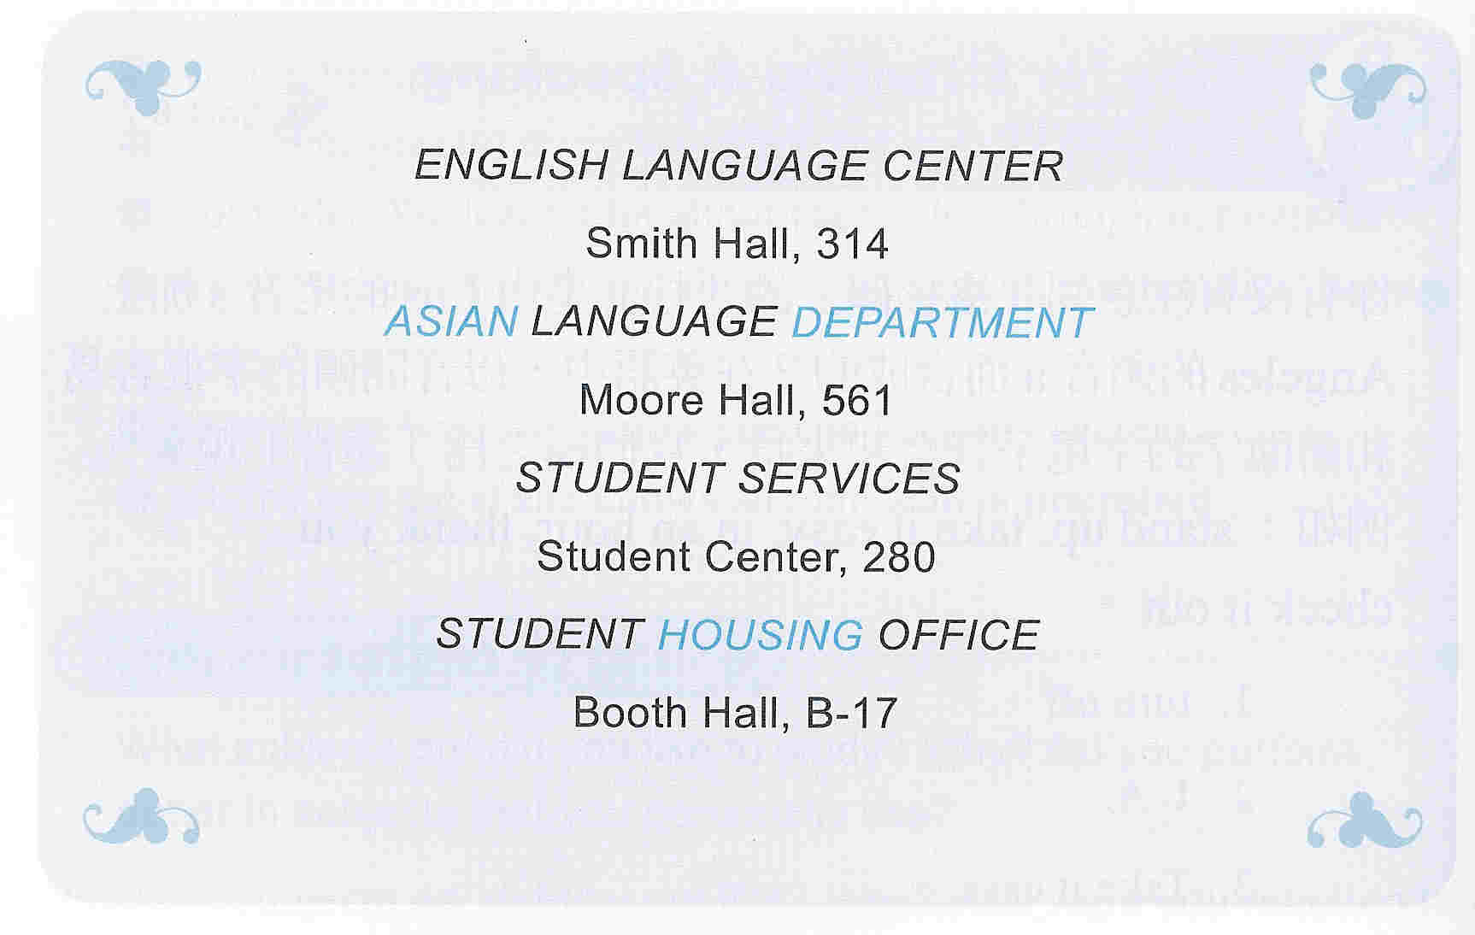
3. 回答問題
(11) Where do you go to find out about a Chinese course?
A. Smith Hall
B. Moore Hall
C. Student Center
D. Booth Hall
(12) Ryan is looking for a place to live. Where should he go?
A. Booth Hall
B. Smith Hall
C. Moore Hall
D. Student Center
4. 回答問題
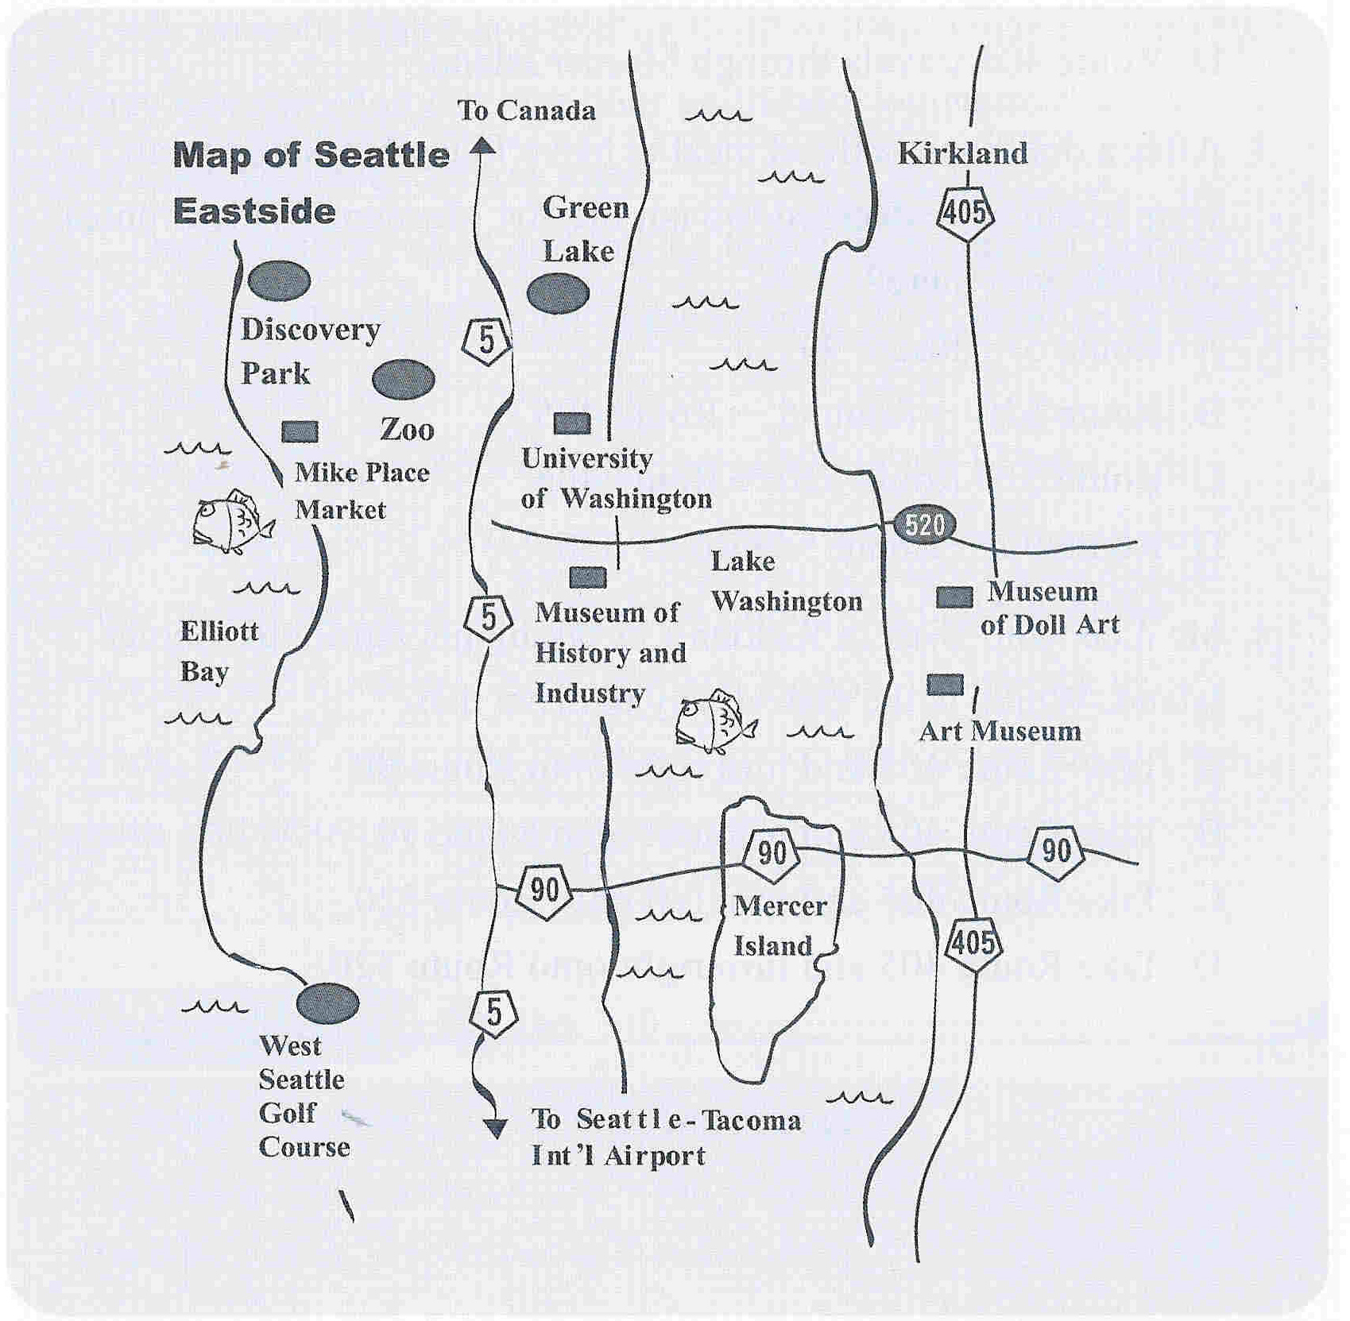
(13) Which of the following is true?
A. Route 90 travels north-south.
B. Route 5 travels east-west.
C. Route 405 takes you to Kirkland.
D. Route 405 travels through Mercer Island.
(14) After a visit at the Art Museum, your friend has decided to go back to Canada. Which routes will take him there?
A. Route 405 Route 90
B. Route 405 Route 520 Route 5
C. Route 90 Route 5
D. Route 90 Route 5 Route 520
(15) Mr. Lee, who lives in Kirkland, is taking his family to Mercer Island. Which is the fastest way to drive there?
A. Take Route 405 and turn right onto Route 520.
B. Take Route 405 and turn left onto Route 90.
C. Take Route 405 and turn left onto Route 520.
D. Take Rout 405 and turn right onto Route 90.

IV. 寫作測驗
句子改寫:
- How is the weather in Hong Kong today?
What ________________________in Hong Kong today?
- It was cold and rainy, but Mr. White went hiking.
Although ______________, _______________________.
合併句子:
- Frank is very young.
He can’t walk through the forest by himself.
Frank is too _________________ to _________________ by himself.
- There’s going to be a storm.
I won’t be able to go on a picnic.
________________________________ because _________________________.
重組:
- Taipei / is / in / 30°C / temperature
The _______________________________.
- is / taken out / Sue / every night / garbage / by
The _______________________________.

