考 試 命 題 紙
注意： 1、本原稿直接製版請以黑色原子筆正楷書寫並自行斟酌答案之空格 命題者： 張 柏 芳 老 師
2、試題難易請適當分配 科目：
3、考試時間 60 分鐘 （✓）學生需要答案紙，請將答案寫在答案紙上。
4、請於 月 日以前送交課務組 （ ）學生不需要答案紙，請將答案寫在試題紙上。

中華技術學院九十六學年度第二學期日間部四技一年級英文期末考前複習卷 共 2 頁 第 1 頁
考試科目：英文二 （✓）不可使用計算機 班級: 學號: 姓名:
A. Vocabulary (字彙選擇。答案請寫在答案卷上，否則不予計分): 20%
- You can’t always trust the ____ forecast because sometimes the weather is hard to predict.(A. climate B. weather C. whether)
- It is going to rain so all of you had better bring _______.(A. sunglasses B. coolers C. umbrellas)
- Every year several _____ always hit Taiwan with strong wind and heavy rain and cause much damage to the crops.(A. raincoats
B. typhoons C. earthquakes )
- If the rain doesn’t stop, we will have to change the _______.(A. date B. day C. dad )
- “A device that produces electricity to provide power” means a _____.(A. flashlight B. battery C. butterfly )
- We can’t have a picnic in the rain! The food will get____. (A. wet B. wait C. weight )
- It will clear up by Thursday. Don’t _____ about our picnic. (A. worry B. worse C. worthy )
- A(n)____ is a man from whom someone rents a room or building. (A. department B. landlord C. apartment )
9. I’m going to compare and contrast ________ and modern roles of women in Taiwan. (A. conditional B. traditional C. additional )
  - “A round stick of wax which gives light when it burns” means ____ (A. a match B. a candle C. a handle )
B. Choose the correct answer (請選出正確答案。答案請寫在答案卷上，否則不予計分): 30%
1. Well, if it stops ___ by Thursday, we can still have our school picnic. { (A) to rain (B) rainy (C) raining }
2. Excuse me, Professor Stevens, could you tell me ____ your office hours are? . { (A) that (B) when (C) whom }
3. Have you tried looking ___ the Internet ___ old news articles? {(A) in, at (B) on, for (C) at, into }
4. The parents were disappointed ___ their son. {(A) for (B) with (C) about }
5. The students were tired ___ the English exercise. {(A) at (B) with (C) of )
6. She is interested _____ classical music. {(A) to (B) in (C) on }
7. I have a few books ____ you might find useful. Why don’t you ___ these for a while?
{(A) which, lend (B) who, owe (C) that, borrow }
8. ___ you have a happy married life! {(A) Will (B) May (C) Can }
9. You’d better ____if you want to catch your plane. {(A) hurry (B) to hurry (C) hurried }
10. Would you mind _____ down the music? I am trying to get some sleep. {(A) to turn (B) turning (C) turns }
11. These plants need to _____ every day. {(A) water (B watering (C) be watered (D) be watering }
12. Your new skirt is too long. Why don’t you get it ____? {(A) short (B) shorten (C) shortened }
13. It’s dangerous to ride with a ______ driver. {(A) drink (B) drank (C) drunk }
14. You ____ stop before a stop sign or you’ll be fined NT$1,000. {(A) would (B) could (C) must }
15. Children under six ____ be left alone at home or in the car. {(A) might not (B) shouldn’t (C) don’t have to }

C. Write correct answers according to the following statements given (依下列敘述寫出正確答案): 15%
句子改寫 (Adapt the two following sentences) 答案請寫在答案卷上，否則不予計分
1. How’s the weather in Hong Kong today?
 What ____________________________________________ today?
2. It was cold and rainy, but Mr. White went hiking.
 Although _______________________________________________.
句子合併 (Combine the two sentences given in each question into one by a conjunction or conjunctive phrase)
- The shower stopped. The children went out to play.
 __________________________________ as soon as ___________________________
2. There’s going to be a storm. I won’t be able to go on a picnic
 ________________________________________ because _____________________________.
重組 (Rearrange the sentence with scrambled/random words)
1. The ___________________________________________________.
Taipei / in / is / temperature / 30 ºC
中華技術學院九十六學年度第二學期日間部四技一年級英文期末考前複習卷 共 2 頁 第 2 頁
考試科目：英文二 （✓）不可使用計算機 班級: 學號: 姓名:

- Cloze test (克漏字測驗。答案請寫在答案卷上，否則不予計分): 20%
When the weather report gave a typhoon warning last month, we had some excitement here because it was the first typhoon
after Greg and I _(1)_.
My parents called and told us to go to their house right away. They were worried our first-floor apartment would_(2)_ because we lived in a low area.
Greg’s father called and told us to get ready _(3)_ the typhoon. He said we should buy a lot of food, water, and batteries_(4)_a power failure.
He also suggested that we _(5)_ water in a bathtub. Our landlord,_(6)_ lived next door, came and _(7)_ us how to put tape on our windows. He was _(8)_ _(9)_us some candles and matches. Just when we thought we were _(10)_ready, the TV news said that the typhoon was going toward the north and wouldn’t hit this area at all!

1. (A) was married (B) were married to (C) got married (D) got married to
2. (A) flood (B) blood (C) be flooded (D) be blooded
3. (A) for (B) at (C) to (D) on
4. (A) in the case of (B) in case of (C) in case that (D) in case
5. (A) stored (B) store (C) stores (D) storing
6. (A) whom (B) whose (C) who (D) which
7. (A) teach (B) teaches (C) is teaching (D) taught
8. (A) enough kind (B) kind enough (C) kindly enough (D) enough kindly
9. (A) to offering (B) by offering (C) to offer (D) by offer
10(A) fully (B) folly (C) fool (D) full

- Reading comprehension (閱讀理解右圖並回答下列各題。答案請寫在答案卷上，否則不予計分): 15%
1. Which of the following is true?
  - Route 5 takes you to Kirkland.
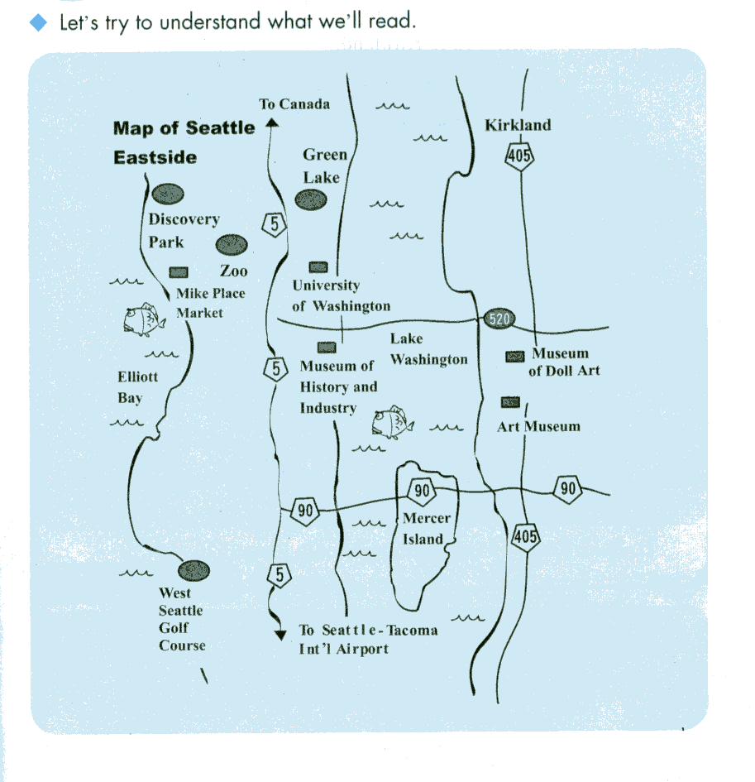
  - Route 520 travels north-south.
  - Route 405 travels through Mercer Island.
  - Route 90 travels east-west.

2. Mr. Lee, who lives in Kirkland, is taking his family to
Mercer Island. Which is the fastest way to drive there?
A. Take Route 405 and turn right onto Route 520.
B. Take Route 405 and turn right onto Route 90.
C. Take Route 405 and turn left onto Route 520.
D. Take Route 405 and turn left onto Route 90.

3. You are going to pick up a friend who just flew to Seattle.
Which Route do you take to meet him?
A. Route 90 B. Route 5 C. Route 405 D. Route 520

4. After a delicious seafood meal at Mike Place Market, you and
your friend have decided to visit the Art Museum. Which routes
will take you there?
  - Route 5 ] Route 90
  - Route 5 ] Route 520 ]Route 405
  - Route 90 ] Route 5 ] Route 520
  - Route 520 ] Route 5 ]Route 405

5. According to the Map of Seattle, which routes can you take to
Canada?
A. Routes 5 and 90 B. Routes 520 and 405
C. Routes 520 and 90 D. Routes 5 and 405

中華技術學院九十六學年度第二學期日間部四技一年級英文期末考前複習卷 共 2 頁 第 1 頁

答案請寫在答案卷上，否則不予計分

答 案 卷

考試科目：英文二 （✓）不可使用計算機 班級: 學號: 姓名:
A. Vocabulary (字彙選擇): 20%
1. ( B ) 2. ( C ) 3. ( B ) 4. ( A ) 5. ( B ) 6. ( A ) 7. ( A ) 8. ( B ) 9. ( B ) 10. ( B )

B. Choose the correct answer (請選出正確答案): 30%
1. ( C ) 2. ( B ) 3. ( B ) 4. ( B ) 5. ( C ) 6. ( B ) 7. ( C ) 8. ( B ) 9. ( A ) 10. ( B )

11. ( C ) 1 2. ( C ) 1 3. ( C ) 1 4. ( C ) 15. ( B )

C. Write correct answers according to the following statements given (依下列敘述寫出正確答案): 15%
句子改寫 (Adapt the two following sentences)
1. How’s the weather in Hong Kong today?
 What __is the weather like in Hong Kong_today?
2. It was cold and rainy, but Mr. White went hiking.
 Although _it was cold and rainy, Mr. White went hiking__.
句子合併 (Combine the two sentences given in each question into one by a conjunction or conjunctive phrase)
- The shower stopped. The children went out to play.
 _The children went out to play_ as soon as _the shower stopped_.
2. There’s going to be a storm. I won’t be able to go on a picnic
 _I won’t be able to go on a picnic_ because _there’s going to be a storm_.
重組 (Rearrange the sentence with scrambled/random words)
1. The _temperature in Taipei is 30 ºC __.
Taipei / in / is / temperature / 30 ºC

中華技術學院九十六學年度第二學期日間部四技一年級英文期末考前複習卷 共 2 頁 第 2 頁
考試科目：英文二 （✓）不可使用計算機 班級: 學號: 姓名:

D. Cloze test (克漏字測驗): 20%

1. ( C ) 2. ( C ) 3. ( A ) 4. ( B ) 5. ( B ) 6. ( C ) 7. ( D ) 8. ( B ) 9. ( C ) 10. ( A )

E. Reading comprehension (閱讀理解右圖並回答下列各題): 15%
1. ( D ) 2. ( B ) 3. ( B ) 4. ( B ) 5. ( D )

